Submitted by - Annie Renita, Guided by - Dr. Carlo Lipizzi.

Stevens Institute of technology - School of System and Enterprise, EM 624 - Informatics for Engineering Management course.

Suicide in the United States

***Abstract*-****- In the United States, suicide is a huge public health concern. Among rich countries, the country has one of the highest suicide rates. According to the CDC's National Center for Health Statistics, there were 48,344 suicides registered in 2018, up from 42,773 in 2014. (NCHS). Between 1999 and 2014, the yearly suicide rate in the United States climbed by 24%, from 10.5 to 13.0 suicides per 100,000 persons, the highest rate in 28 years. Suicide is thought to be under-reported in general due to the shame attached to it. The Centers for Disease Control and Prevention (CDC) released data in April 2016 showing that the suicide rate in the United States had reached a 30-year high, and then released more data in June 2018 showing that the rate has continued to rise and has increased in every U.S. state except Nevada since 1999. Suicide, drug overdoses, and alcoholism are all on the rise.**

**The data set being analyzed is from the year 2012 to 2014.**

# Introduction

Suicide is defined as self-inflicted death with the purpose to die. A suicide attempt occurs when someone intentionally damages oneself with the purpose of ending their life but does not die as a result of their actions.

Many variables can either enhance or decrease the risk of suicide. Suicide has been linked to several types of injury and violence. People who have been exposed to violence, such as child abuse, bullying, or sexual assault, are more likely to commit suicide. Suicidal thoughts and actions can be reduced by being linked to family and community support and having simple access to health care.

Between 1999 and 2019, the number of people who committed suicide climbed by 33%. In the United States, suicide is the tenth highest cause of death. In 2019, it was responsible for around 47,500 deaths, or roughly one fatality every 11 minutes. The number of persons who contemplate suicide or try it is considerably larger.

The investigation should take into account the elements that influence the occurrences and strive to answer the following questions:

Is age a factor in the prevalence of suicides?

Is one gender more likely to commit suicide than the other?

Is any combination of variables more likely to lead to suicide than others?

# Background

Suicide rates in the United States have risen dramatically in the twenty-first century, drawing public and clinical attention. According to studies, despite all attempts to reduce suicide rates, they have gradually climbed by about 2% each year from 2006 to 2014. According to a national epidemiologic study of 69,341 individuals in the United States, the percentage of adults who attempted suicide climbed from 0.62 percent in 2004-2005 to 0.79 percent in 2012-2013. As a result, physicians are trying to figure out if this is a coincidence or if there is a countrywide surge in suicide attempts. Trends in suicide attempts are described among socio-demographic and clinical categories in order to achieve this. Suicide attempts are shown to have disproportionately high rates among "younger persons with less formal education and those with antisocial personality disorder, anxiety disorders, depressive disorders, and a history of violence."

# Data Description

Suicide in the United States data set from the year 2012 to 2014 being analyzed has 11 columns and 100798 rows of data.

The data has information about the age of the people who suicide, the intent, the sex of the person, race of the person, place where they committed suicide , education. The investigation/ analysis takes into account the age, race, place, intent being only suicide, education.

The age of the people committed suicide being 9 to 102 years.

The intent of people committing suicide being suicide, accidental, homicide, undetermined,etc. The sex of the people being male or female. The race of the people being White, Black, Native American, Hispanic, etc. The place where people commit suicide being home, street, trade / service area, etc. The education of the people committing suicide being High school, some college,BA+, etc.

# Data Preparation

So firstly, to start the analysis via python code, the data file which was in ‘.csv’ format was read and stored into a variable. The data set did not need much cleaning as it was simple , structured and easy to handle. The record having missing values were discarded as it would not help in the overall analysis of the data-set.

# Methodology

First using pandas, the ‘csv’ format data file was read and stored in ‘df’ variable. So,after the file was read and stored in the variable, the program checks for any missing values which has ‘N/A’ value written in the data cell and prints the number of values missing under each column. After the number of missing data is identified, the data having ‘N/A’ value are dropped as it does not help in the overall analysis. The program then determines and prints the total number of distribution of values in the data-set provided of suicide in the United States.

The program then determines the oldest and youngest person who committed suicide in the years 2012 - 2014 and prints it.

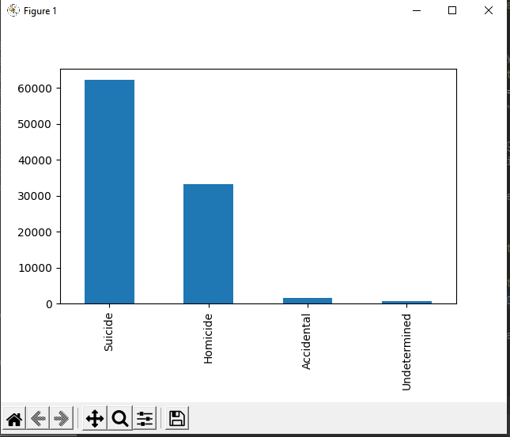

Figure 1: Intent of suicide

According to the analysis, more than 60,000 people have taken their own lives, 30,000 to 40,000 people have committed a homicide, about less than 10,000 people have committed accidental suicide and the intent was undetermined least number of people who have committed suicide.

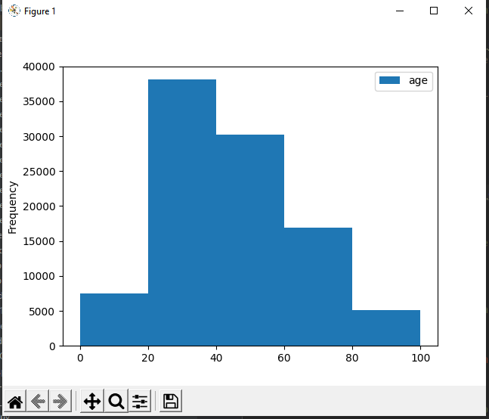

Figure 2: Age of people who commit suicide

According to the analysis, approximately 35,000 to 40,000 people from the age group of 20 to 40 years have committed suicide.

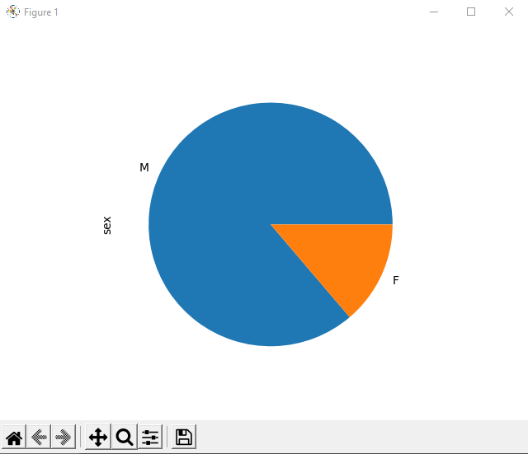

Figure 3: Sex of the people committing suicide

According to the analysis, most of the suicides are committed by males compared to females.

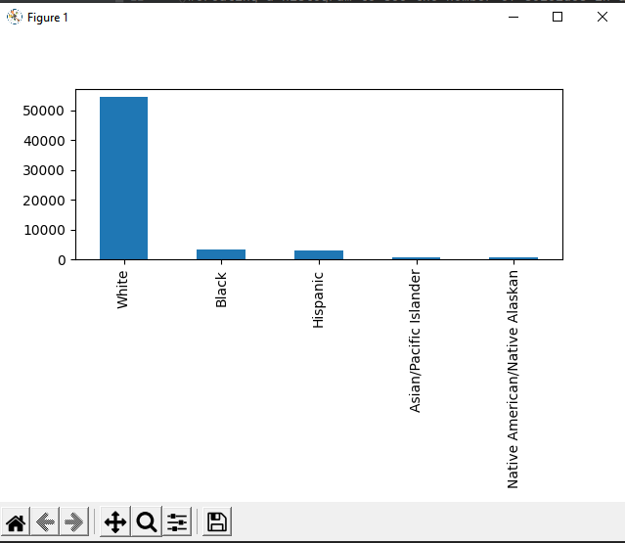

Figure 4: Race of people committing suicide

According to the analysis performed, suicide was performed by White people, next by Black people, after which Hispanic, Asian / Pacific Islander and Native American/ Native Alaskans.

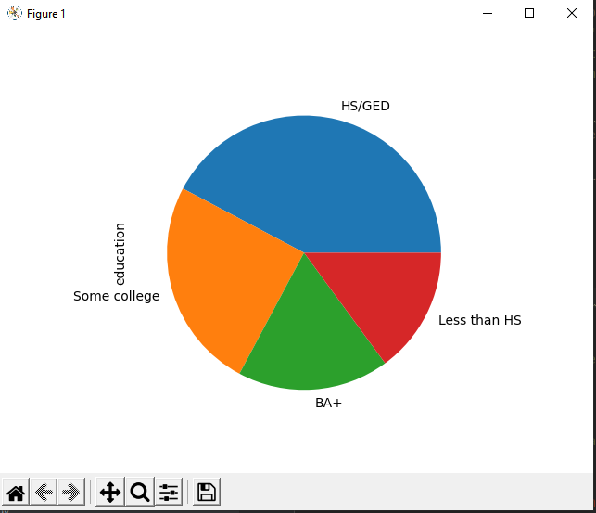

Figure 5: Education of people committing suicide

According to the analysis, most of people who committed suicide

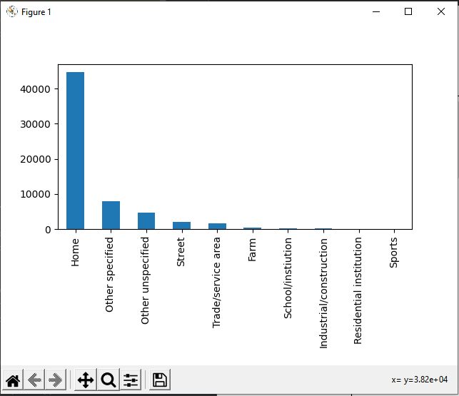

Figure 6: Place where people are committing suicide

According to the analysis, more than 40,000 people committed suicide at home.

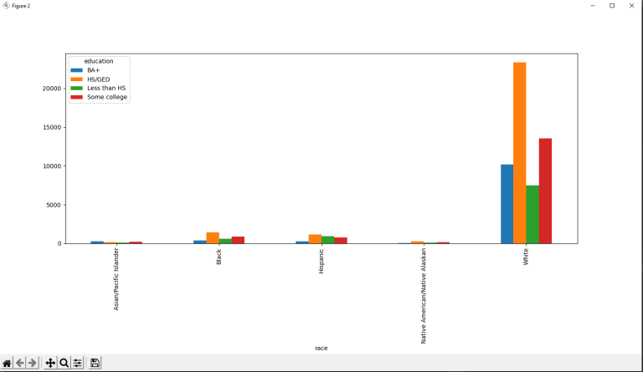

Figure 7: Sub category analysis of race and education

# Conclusion

The conclusion of the subcategory analysis of race and education of the people who committed the suicide are white people who are in high school.

# Reference

The data for this study can be found at the following URL:

<https://github.com/fivethirtyeight/guns-data/blob/master/full_data.csv>